BAGIANN ADMIN BIMBLEAJA

1.HALAMAN KELOLA MATERI & SOAL

Ini codingan nya;

<!DOCTYPE html>
<html lang="en">
<head>
<meta charset="UTF-8">
<meta name="viewport" content="width=device-width, initial-scale=1.0">
<title>Kelola Materi & Soal | Admin Panel</title>
<script src="https://cdn.tailwindcss.com"></script>
<link rel="stylesheet" href="https://cdnjs.cloudflare.com/ajax/libs/font-awesome/6.4.0/css/all.min.css">
<style>
/* Custom scrollbar */
::-webkit-scrollbar {
width: 8px;
}
::-webkit-scrollbar-track {
background: #f1f1f1;
}
::-webkit-scrollbar-thumb {
background: #888;
border-radius: 4px;
}
::-webkit-scrollbar-thumb:hover {
background: #555;
}

.status-badge {
transition: all 0.3s ease;
}
.status-badge:hover {
transform: scale(1.05);
}

.search-focus:focus {
box-shadow: 0 0 0 3px rgba(59, 130, 246, 0.3);
border-color: #3B82F6;
}

.material-card:hover {
box-shadow: 0 10px 20px rgba(0,0,0,0.15);
transform: translateY(-2px);
}

.dropdown-content {
opacity: 0;
visibility: hidden;
transform: translateY(-10px);
transition: all 0.3s ease;
}
.dropdown:hover .dropdown-content {
opacity: 1;
visibility: visible;
transform: translateY(0);
}
</style>
</head>
<body class="bg-gray-100">
<div class="flex h-screen overflow-hidden">
<!-- Sidebar -->
<div class="hidden md:flex md:flex-shrink-0">
<div class="flex flex-col w-64 bg-blue-800 text-white">
<div class="flex items-center justify-center h-16 px-4 py-5 border-b border-blue-700">
<div class="flex items-center">
<img src="https://placehold.co/40x40" alt="Education platform logo with graduation cap icon" class="h-8 w-8 rounded-full">
<span class="ml-3 text-xl font-bold">EduManage</span>
</div>
</div>
<div class="flex flex-col flex-grow pt-5 pb-4 overflow-y-auto">
<nav class="flex-1 px-4 space-y-2">
<a href="dashboard.php" class="flex items-center px-4 py-2 text-sm font-medium rounded-lg bg-blue-700 text-white">
<i class="fas fa-home mr-3"></i> Dashboard
</a>
<a href="#" class="flex items-center px-4 py-2 text-sm font-medium rounded-lg hover:bg-blue-700">
<i class="fas fa-users mr-3"></i> Manage Users
</a>
<a href="#" class="flex items-center px-4 py-2 text-sm font-medium rounded-lg bg-blue-900 text-white">
<i class="fas fa-book mr-3"></i> Kelola Materi & Soal
</a>
<a href="#" class="flex items-center px-4 py-2 text-sm font-medium rounded-lg hover:bg-blue-700">
<i class="fas fa-chart-bar mr-3"></i> Analytics
</a>
</nav>
</div>
<div class="px-4 py-4 border-t border-blue-700">
<div class="flex items-center">
<img src="https://placehold.co/40x40" alt="Admin profile picture showing professional headshot" class="h-9 w-9 rounded-full">
<div class="ml-3">
<p class="text-sm font-medium">Admin</p>
<p class="text-xs text-blue-200">admin@edumanage.edu</p>
</div>
</div>
<button class="mt-3 w-full flex items-center justify-center px-4 py-2 text-sm text-blue-100 rounded-lg hover:bg-blue-700">
<i class="fas fa-sign-out-alt mr-2"></i> Logout
</button>
</div>
</div>
</div>

<!-- Main content -->
<div class="flex-1 overflow-auto">
<!-- Top navigation -->
<div class="bg-white shadow-sm">
<div class="flex items-center justify-between h-16 px-4">
<div class="flex items-center">
<button class="md:hidden p-2 rounded-md text-gray-600 hover:text-gray-900 focus:outline-none">
<i class="fas fa-bars"></i>
</button>
<h1 class="ml-2 text-xl font-semibold text-gray-800">Kelola Materi & Soal</h1>
</div>
<div class="flex items-center space-x-4">
<div class="relative">
<button class="p-2 text-gray-600 rounded-full hover:bg-gray-100 focus:outline-none">
<i class="fas fa-bell"></i>
</button>
<span class="absolute top-0 right-0 bg-red-500 text-white text-xs rounded-full h-5 w-5 flex items-center justify-center">3</span>
</div>
</div>
</div>
</div>

<!-- Content -->
<div class="p-6">
<!-- Filters and actions -->
<div class="flex flex-col md:flex-row justify-between items-start md:items-center mb-6 gap-4">
<div class="flex flex-col md:flex-row gap-3">
<div class="relative">
<select class="block appearance-none bg-white border border-gray-300 text-gray-700 py-2 px-4 pr-8 rounded-lg leading-tight focus:outline-none focus:border-blue-500">
<option>Semua Jenjang</option>
<option>SD</option>
<option>SMP</option>
<option>SMA</option>
</select>
<div class="pointer-events-none absolute inset-y-0 right-0 flex items-center px-2 text-gray-700">
<i class="fas fa-chevron-down"></i>
</div>
</div>
<div class="relative">
<select class="block appearance-none bg-white border border-gray-300 text-gray-700 py-2 px-4 pr-8 rounded-lg leading-tight focus:outline-none focus:border-blue-500">
<option>Semua Mapel</option>
<option>Matematika</option>
<option>Bahasa Indonesia</option>
<option>IPA</option>
<option>IPS</option>
</select>
<div class="pointer-events-none absolute inset-y-0 right-0 flex items-center px-2 text-gray-700">
<i class="fas fa-chevron-down"></i>
</div>
</div>
<div class="relative">
<select class="block appearance-none bg-white border border-gray-300 text-gray-700 py-2 px-4 pr-8 rounded-lg leading-tight focus:outline-none focus:border-blue-500">
<option>Semua Status</option>
<option>Menunggu Verifikasi</option>
<option>Siap Tampil</option>
<option>Ditolak</option>
</select>
<div class="pointer-events-none absolute inset-y-0 right-0 flex items-center px-2 text-gray-700">
<i class="fas fa-chevron-down"></i>
</div>
</div>
</div>
<div class="w-full md:w-auto">
<div class="relative">
<input type="text" placeholder="Cari materi atau soal..." class="search-focus w-full md:w-64 px-4 py-2 border border-gray-300 rounded-lg pl-10 focus:outline-none focus:shadow-outline">
<div class="absolute left-3 top-2.5 text-gray-400">
<i class="fas fa-search"></i>
</div>
</div>
</div>
</div>

<!-- Tabs -->
<div class="mb-6">
<div class="flex border-b border-gray-200">
<button class="py-2 px-4 border-b-2 border-blue-500 font-medium text-blue-600 focus:outline-none">
Materi Pembelajaran
</button>
<button class="py-2 px-4 text-gray-600 hover:text-gray-800 focus:outline-none">
Bank Soal
</button>
<button class="py-2 px-4 text-gray-600 hover:text-gray-800 focus:outline-none">
Kategori
</button>
</div>
</div>

<!-- Materials content -->
<div class="bg-white rounded-lg shadow overflow-hidden">
<!-- Table header -->
<div class="grid grid-cols-12 gap-4 p-4 bg-gray-50 border-b border-gray-200 font-medium text-gray-700">
<div class="col-span-1">No</div>
<div class="col-span-4">Judul Materi</div>
<div class="col-span-2">Guru</div>
<div class="col-span-2">Jenjang & Mapel</div>
<div class="col-span-2">Tanggal Upload</div>
<div class="col-span-1">Status</div>
</div>

<!-- Table rows -->
<?php
// Mock data (in production this would come from database)
$materials = [
[
'title' => 'Pemrograman JavaScript Dasar',
'teacher' => 'John Doe',
'level' => 'SMA',
'subject' => 'Informatika',
'date' => '15-03-2023',
'status' => 'pending',
'topics' => ['JavaScript', 'Pemrograman']
],
[
'title' => 'Penjumlahan Pecahan',
'teacher' => 'Jane Smith',
'level' => 'SMP',
'subject' => 'Matematika',
'date' => '10-03-2023',
'status' => 'approved',
'topics' => ['Pecahan', 'Aritmatika']
],
[
'title' => 'Sejarah Kemerdekaan Indonesia',
'teacher' => 'Budi Santoso',
'level' => 'SD',
'subject' => 'IPS',
'date' => '05-03-2023',
'status' => 'rejected',
'topics' => ['Sejarah', 'Indonesia']
],
[
'title' => 'Struktur Sel Hewan',
'teacher' => 'Anita Wardani',
'level' => 'SMA',
'subject' => 'Biologi',
'date' => '02-03-2023',
'status' => 'approved',
'topics' => ['Biologi Sel', 'Struktur']
],
];

foreach ($materials as $index => $material):
$statusClass = $material['status'] === 'approved' ? 'bg-green-100 text-green-800' :
($material['status'] === 'pending' ? 'bg-yellow-100 text-yellow-800' : 'bg-red-100 text-red-800');
$statusText = $material['status'] === 'approved' ? 'Siap Tampil' :
($material['status'] === 'pending' ? 'Menunggu' : 'Ditolak');
?>
<div class="grid grid-cols-12 gap-4 p-4 border-b border-gray-200 hover:bg-gray-50 transition-colors">
<div class="col-span-1 flex items-center"><?= $index + 1 ?></div>
<div class="col-span-4">
<div class="font-medium text-blue-600"><?= htmlspecialchars($material['title']) ?></div>
<div class="text-sm text-gray-500 mt-1">
Topik: <?= implode(', ', $material['topics']) ?>
</div>
</div>
<div class="col-span-2 flex items-center">
<img src="https://placehold.co/40x40" alt="Teacher profile picture" class="h-8 w-8 rounded-full mr-2">
<?= htmlspecialchars($material['teacher']) ?>
</div>
<div class="col-span-2 flex items-center">
<?= htmlspecialchars($material['level']) ?> &middot; <?= htmlspecialchars($material['subject']) ?>
</div>
<div class="col-span-2 flex items-center">
<?= $material['date'] ?>
</div>
<div class="col-span-1 flex items-center">
<div class="relative">
<span class="status-badge px-2 py-1 rounded-full text-xs font-medium <?= $statusClass ?>"><?= $statusText ?></span>
</div>
</div>
</div>
<?php endforeach; ?>
</div>

<!-- Pagination -->
<div class="flex items-center justify-between mt-6">
<div class="text-sm text-gray-700">
Menampilkan <span class="font-medium">1</span> sampai <span class="font-medium">4</span> dari <span class="font-medium">10</span> entri
</div>
<div class="flex space-x-2">
<button class="px-3 py-1 rounded border border-gray-300 bg-white text-gray-700 hover:bg-gray-50 disabled:opacity-50" disabled>
Previous
</button>
<button class="px-3 py-1 rounded border border-gray-300 bg-white text-gray-700 hover:bg-gray-50">
1
</button>
<button class="px-3 py-1 rounded border border-gray-300 bg-white text-gray-700 hover:bg-gray-50">
2
</button>
<button class="px-3 py-1 rounded border border-gray-300 bg-white text-gray-700 hover:bg-gray-50">
3
</button>
<button class="px-3 py-1 rounded border border-gray-300 bg-white text-gray-700 hover:bg-gray-50">
Next
</button>
</div>
</div>

<!-- Material detail modal -->
<div class="fixed inset-0 overflow-y-auto z-50 hidden" id="materialModal">
<div class="flex items-center justify-center min-h-screen pt-4 px-4 pb-20 text-center">
<div class="fixed inset-0 transition-opacity">
<div class="absolute inset-0 bg-gray-500 opacity-75"></div>
</div>
<div class="inline-block bg-white rounded-lg text-left overflow-hidden shadow-xl transform transition-all max-w-4xl w-full">
<div class="bg-white px-4 pt-5 pb-4 sm:p-6 sm:pb-4">
<div class="flex justify-between items-start">
<h3 class="text-lg leading-6 font-medium text-gray-900">Detail Materi Pembelajaran</h3>
<button class="text-gray-400 hover:text-gray-500" onclick="document.getElementById('materialModal').classList.add('hidden')">
<i class="fas fa-times"></i>
</button>
</div>
<div class="mt-6 grid grid-cols-1 md:grid-cols-4 gap-4">
<div>
<h4 class="font-medium text-gray-700 mb-2">Jenjang</h4>
<p class="text-gray-900" id="modalLevel">SMA</p>
</div>
<div>
<h4 class="font-medium text-gray-700 mb-2">Mata Pelajaran</h4>
<p class="text-gray-900" id="modalSubject">Informatika</p>
</div>
<div>
<h4 class="font-medium text-gray-700 mb-2">Topik</h4>
<p class="text-gray-900" id="modalTopics">JavaScript, Pemrograman</p>
</div>
<div>
<h4 class="font-medium text-gray-700 mb-2">Tanggal Upload</h4>
<p class="text-gray-900" id="modalDate">15-03-2023</p>
</div>
</div>
<div class="mt-4">
<h4 class="font-medium text-gray-700 mb-2">Guru</h4>
<div class="flex items-center">
<img src="https://placehold.co/40x40" alt="Teacher profile picture" class="h-10 w-10 rounded-full mr-3">
<div>
<p class="text-gray-900 font-medium" id="modalTeacher">John Doe</p>
<p class="text-gray-500 text-sm">john.doe@school.edu</p>
</div>
</div>
</div>
<div class="mt-6">
<h4 class="font-medium text-gray-700 mb-2">Deskripsi Materi</h4>
<div class="bg-gray-50 p-4 rounded-lg" id="modalDescription">
<p>Materi ini berisi pengenalan dasar-dasar pemrograman menggunakan JavaScript. Meliputi konsep variabel, tipe data, operator, percabangan, dan perulangan. Dilengkapi dengan contoh-contoh kode untuk memudahkan pemahaman siswa.</p>
</div>
</div>
<div class="mt-6">
<h4 class="font-medium text-gray-700 mb-2">Dokumen Materi</h4>
<div class="flex flex-wrap gap-3">
<a href="#" class="flex items-center px-3 py-2 bg-blue-50 text-blue-600 rounded-lg hover:bg-blue-100">
<i class="fas fa-file-powerpoint mr-2"></i>
<span>Presentasi.pptx</span>
</a>
<a href="#" class="flex items-center px-3 py-2 bg-gray-50 text-gray-600 rounded-lg hover:bg-gray-100">
<i class="fas fa-file-pdf mr-2"></i>
<span>Modul.pdf</span>
</a>
</div>
</div>
</div>
<div class="bg-gray-50 px-4 py-3 sm:px-6 sm:flex sm:flex-row-reverse">
<button type="button" class="w-full inline-flex justify-center rounded-md border border-transparent shadow-sm px-4 py-2 bg-green-600 text-base font-medium text-white hover:bg-green-700 sm:ml-3 sm:w-auto sm:text-sm">
Setuju &amp; Tandai Siap Tampil
</button>
<button type="button" class="mt-3 w-full inline-flex justify-center rounded-md border border-gray-300 shadow-sm px-4 py-2 bg-white text-base font-medium text-gray-700 hover:bg-gray-50 sm:mt-0 sm:ml-3 sm:w-auto sm:text-sm">
Edit Materi
</button>
<button type="button" class="mt-3 w-full inline-flex justify-center rounded-md border border-transparent shadow-sm px-4 py-2 bg-red-600 text-base font-medium text-white hover:bg-red-700 sm:mt-0 sm:ml-3 sm:w-auto sm:text-sm">
Tolak Materi
</button>
<button type="button" onclick="document.getElementById('materialModal').classList.add('hidden')" class="mt-3 w-full inline-flex justify-center rounded-md border border-gray-300 shadow-sm px-4 py-2 bg-white text-base font-medium text-gray-700 hover:bg-gray-50 sm:mt-0 sm:w-auto sm:text-sm">
Kembali
</button>
</div>
</div>
</div>
</div>
</div>
</div>
</div>

<script>
// Get all table rows and add click event
document.querySelectorAll('.grid.grid-cols-12.gap-4.p-4.border-b').forEach(row => {
row.addEventListener('click', function() {
document.getElementById('materialModal').classList.remove('hidden');
});
});

// Simulate loading material data when clicking a row
function loadMaterialData(title) {
// In a real application, this would be an AJAX call to get the data
document.getElementById('modalTitle').textContent = title;
// More fields would be populated here based on the clicked material
}
</script>
</body>
</html>

Ini hasil tampilan & penjelasan ;

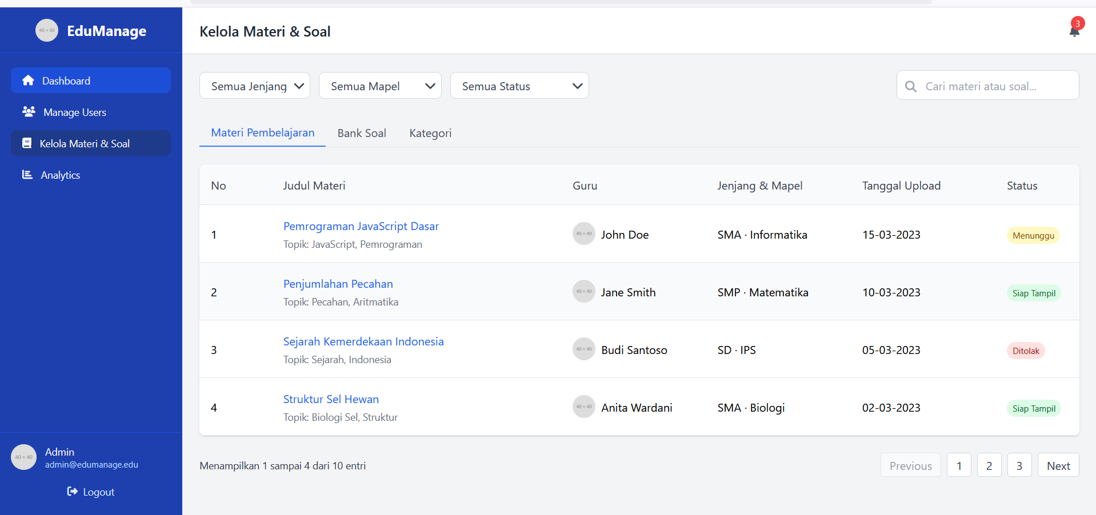

Halaman kelola materi & soal bagian admin ini belum terhubung dengan localhost. Jadi ditampilan ini ada beberpa yg direvisi bagian “ semua jenjang “ diganti dengan kelas

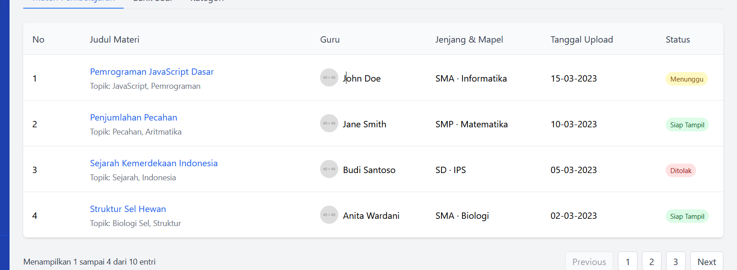

Dibagian ini ketika nanti si admin menyetujui baru bisa tampil diberanda ini, jika materi ditolak materi tersebut tidak dpat bisa tampil, tampilan diatas nanti masuk nya ke database tabel_materi agar menyesuikan database yg sudah ada dulu

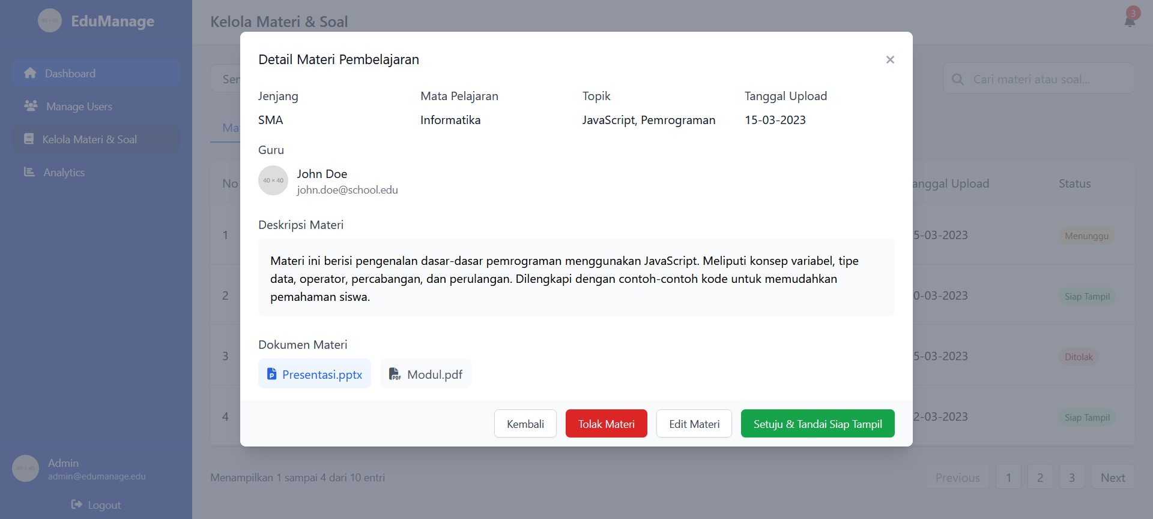

Halaman detail materi pembelajaran ini ada beberapa yg direvisi dibagian jenjang diganti dengan kelas, topik diganti judul, guru diganti tutor, dibagian mata pelajaran ini ngambil data dari tabel kategori_materi, bagian tolak materi dan setujui & tandai siap tampil harus disamakan dgn database yg sama dgn tutor/mentor, selebih nya harus menyesuaikan database yg sudah tersedia, berikut gambar mysql database materi dibawah ini;

a.tabel materi
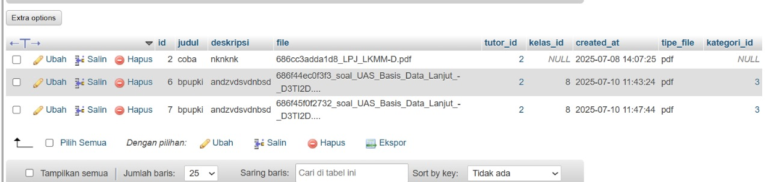

b.tabel kategori_materi
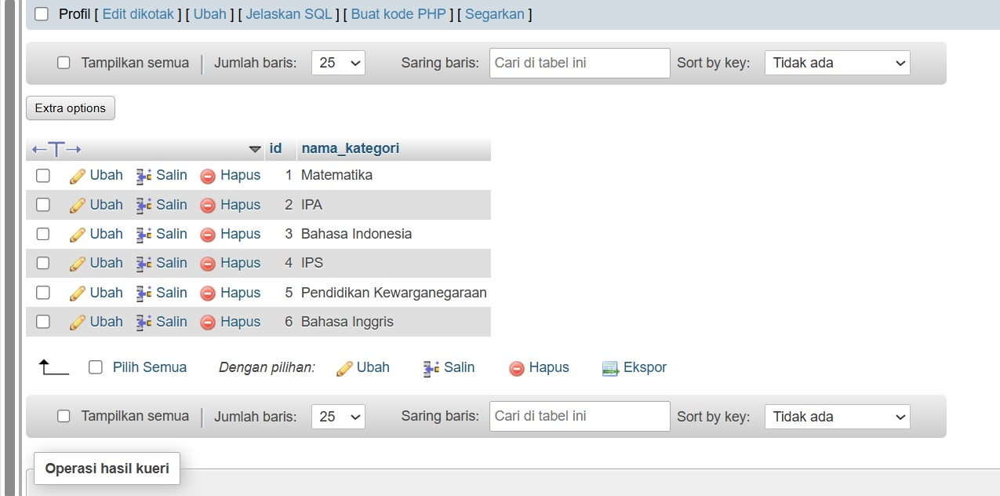

Agar file kelola materi & soal ini bisa selaras dengan database kelompok project terkhsus untuk bagian mentor agar sama – sama terakses ke database yg sama.

